- Šta je to drum i objasniti razvoj drumske infrastrukture u svijetu do danas.
________________________________________________________________________________________________________________________________________________________________________________________________________________________________________________________________________________________________________________________________________________________________________________________________________________________________________________________________________________________________________________________________________________________________________________________________________________________________________________________________________________________________________________________________________________________________________________________________________________________________________________________________________________________________________________________________________________________________________
- Koliko iznosi ukupna dužina drumske mreže u svijetu ?
______________________________________________________________________________
- Na osnovu podataka iz tabele objasniti razmještaj putne mreže po kontinentima
Kontitent | Putna mreža u 000km
Evropa | 6.425,5
Azija | 10.269,5
Afrika | 1.626,5
Sjeverna Amerika | 7.802,5
Južna Amerika | 3.023,4
Australija | 940,0
______________________________________________________________________________________________________________________________________________________________________________________________________________________________________________________________________________________________________________________________________________________________________________________________________________________________________________________________________________________________________________________________________________________________________________________________________________________________________________________________________________________________________________________________
- Koje su prednosti drumskog saobraćaja u odnosu na ostale vidove kopnenog saobraćaja?
__________________________________________________________________________________________________________________________________________________________________________________________________________________________________________________________________________________________________________________________________________________________________________________________________________________________________________________________________________________________________________________________________________________________________
- Navesti istorijski pregled stvaranja automobila.
1500. g._______________________________________________________________________
1769. g.________________________________________________________________________
1860. g.________________________________________________________________________
1867. g.________________________________________________________________________
1885. g.________________________________________________________________________
1890. g.________________________________________________________________________
1895. g.________________________________________________________________________
1913. g.________________________________________________________________________
1919. g.________________________________________________________________________
- Kada su u pitanju drumska vozila, koja vozila dominiraju dominiraju po brojnosti u svijetu?
____________________________________________________________________________________________________________________________________________________________
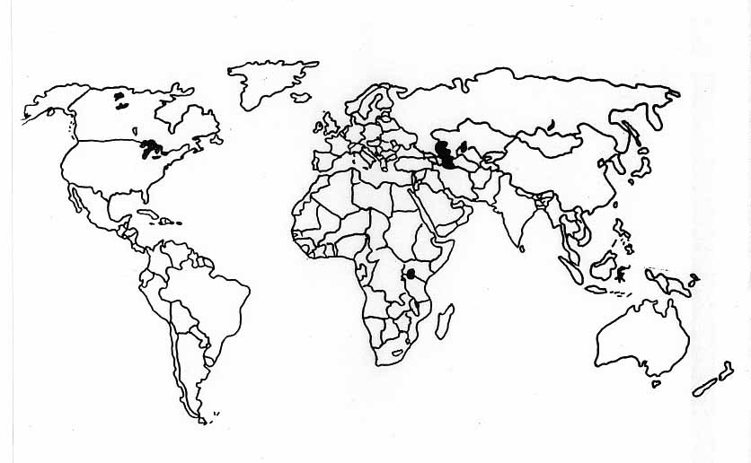
- Na nijemoj karti svijeta metodom šrafa istaći zemlje sa najvećim brojem motornih vozila.

- Od čega zavisi stepen gustine i modernizacije putne mreže? ____________________________________________________________________________________________________________________________________________________________

- Navesti zemlje sa najgušćom mrežom drumskih komunikacija.
________________________________________________________________________________________________________________________________________________________________________________________________________________________________________________________________________________________________________________________
- Kakva je mreža drumskih saobraćajnica na prostoru Afrike?
________________________________________________________________________________________________________________________________________________________________________________________________________________________________________________________________________________________________________________________
- Koji su najznačajniji drumski putevi na području SAD-a I Južne Amerike?
____________________________________________________________________________________________________________________________________________________________________________________________________________________________________________________________________________________________________________________________________________________________________________________________________________________________________________________________________________________
- Navesti istorijski pregled razvoja željezničkog saobraćaja.
1808. g. _______________________________________________________________________
1825. g.________________________________________________________________________
1825. g.________________________________________________________________________
1827. g.________________________________________________________________________
1829. g.________________________________________________________________________
1830. g.________________________________________________________________________
1835. g.________________________________________________________________________
1838. g.________________________________________________________________________
1853. g.________________________________________________________________________
1854. g.________________________________________________________________________
1869. g.________________________________________________________________________
1895. g.________________________________________________________________________
1905. g.________________________________________________________________________
1912. g.________________________________________________________________________
1981. g.________________________________________________________________________
- Koje su najpoznatije transnacionalne željeznice u svijetu, i gdje se nalaze?
__________________________________________________________________________________________________________________________________________________________________________________________________________________________________________________________________________________________________________________________________________________________________________________________________________________________________________________________________________________________________________________________________________________________________
- Šta je omogućilo povećanje brzine i veći obim prevezenog tereta u željezničkom saobraćaju?
__________________________________________________________________________________________________________________________________________________________________________________________________________________________________________

- U drugoj polovini XX vijeka kada je u pitanju razvoj željezničkog saobraćaja na šta se posebno obraća pažnja?
__________________________________________________________________________________________________________________________________________________________________________________________________________________________________________
- Na nijemoj karti svijeta, metodom boja označiti razmještaj željezničke mreže po kontinentima
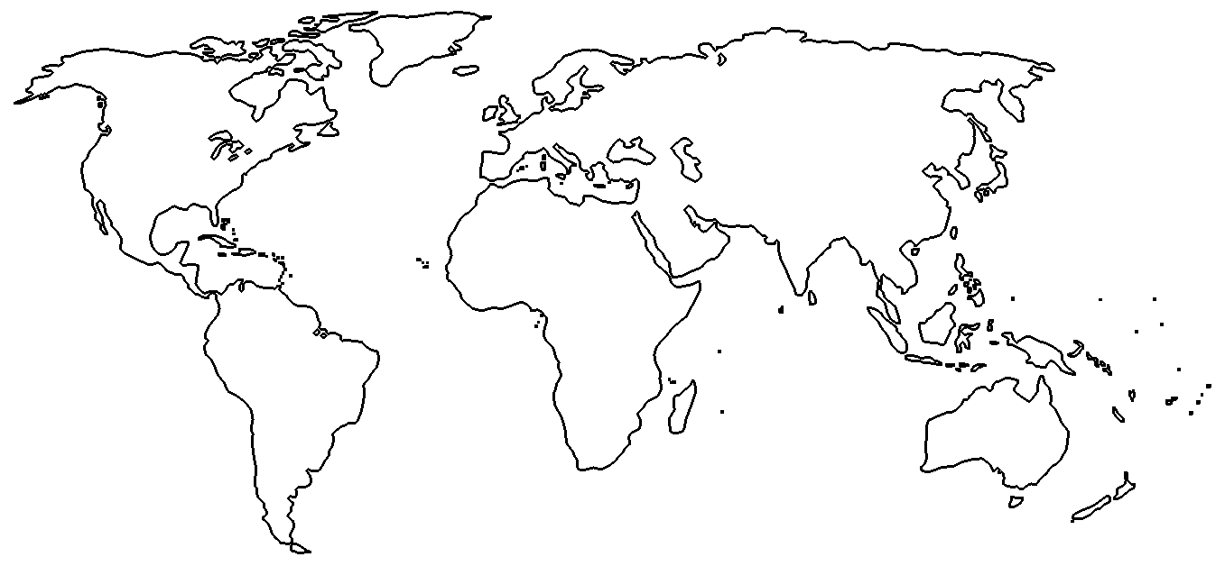

- Koja evropska zemlja ima najveću gustinu željezničke mreže?
______________________________________________________________________________
- Koja dva kontinenta obuhvataju više od 80% željezničkog prometa u svijetu?
______________________________________________________________________________
- U strukturi robnih tokova u okviru svjetske željezničke mreže koje sirovine imaju najveće učešće? ____________________________________________________________________________________________________________________________________________________________
- Šta je to cjevovodni saobraćaj?
____________________________________________________________________________________________________________________________________________________________

- Gdje je najgušća mreža cjevovodne mreže u svijetu?
________________________________________________________________________________________________________________________________________________________________________________________________________________________________________________________________________________________________________________________
- Gdje i kada je izgrađen prvi cjevovod ?
______________________________________________________________________________
- Kuda vode glavni naftovodi u SAD-u?
______________________________________________________________________________________________________________________________________________________________________________________________________________________________________________________________________________________________________________________________________________________________________________________________________
- Šta je to gradski saobraćaj?
____________________________________________________________________________________________________________________________________________________________
- Razvoj gradova uslovljen razvojem saobraćaja prolazi kroz tri faze, objasniti ih.
____________________________________________________________________________________________________________________________________________________________________________________________________________________________________________________________________________________________________________________________________________________________________________________________________________________________________________________________________________________________________________________________________________________________________________________________________________________________________________________________________________________________________________________________________________________________________________________________________________________________________________________________________________________________________________________________________________________________________________________________________________________________________________________________________________________________________________________________________
- Šta su to pješačke zone?
____________________________________________________________________________________________________________________________________________________________
- Šta su to gradski putevi?
____________________________________________________________________________________________________________________________________________________________
- Šta su to transportni terminali?
____________________________________________________________________________________________________________________________________________________________

